Azure Cost Management Design Document

File Transfer details

# Source Details

**Source:** Azure Cost Management

**Dataset owner:** [gpandey@Investcorp.com](mailto:gpandey@Investcorp.com)

Azure Cost Management source details from the Azure cloud system.

Azure cost and usage data that's included in Cost Management. It explains how frequently data is processed, collected, shown, and closed. You're billed for Azure usage monthly. Although billing cycles are monthly periods, cycle start, and end dates vary by subscription type. How often Cost Management receives usage data varies based on different factors. Such factors include how long it takes to process the data and how frequently Azure services emit usage to the billing system.

Cost Management includes all usage and purchases, including reservations and third-party offerings for Enterprise Agreement (EA) accounts. Microsoft Customer Agreement accounts and individual subscriptions with pay-as-you-go rates only include usage from Azure and Marketplace services. Support and other costs aren't included. Costs are estimated until an invoice is generated and don't factor in credits. Cost Management also includes costs associated with New Commerce products like Microsoft 365 and Dynamics 365 that are invoiced along with Azure.

Dashboard Link: <https://app.powerbi.com/links/xTrPgKe5QC?ctid=24eb4179-fa1a-4915-99d9-c93afdf1ebe3&pbi_source=linkShare>

Requirement:

* Usage Details
* Usage Details Amortize
* RI Transactions
* RI Usage Details.

Power Query:

Go to Get Data Option, choose more and select Azure > azure cost management.

Select Enrollment ID, provide the ID (get the ID from the azure admin) and select the no. of months. Shown as below.

Choose all tables even though we choose all the table, but we are going to use only 4 tables. Those tables are based on the requirements.

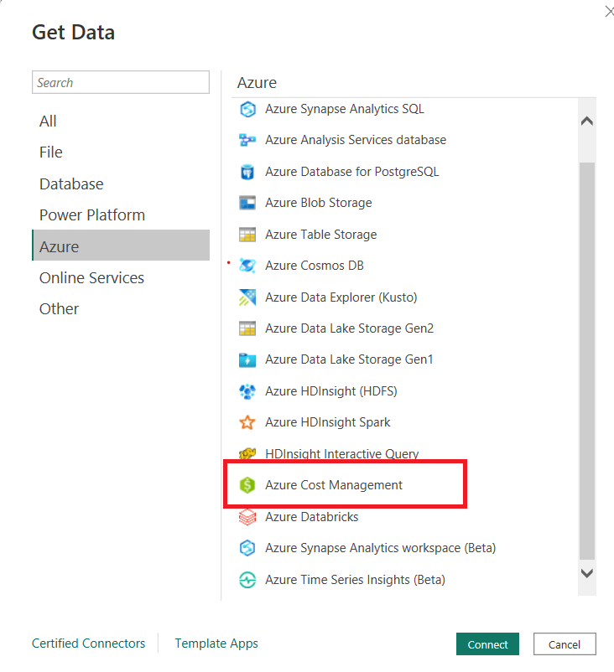

Usage Details:

1. Extract the LOB details from the tag’s column. Extract the chargebacklob information from the tag’s column using column from the examples option.
2. Create a new column “Sub_name” by Removing the first word “Investcorp” and last word “subscription” form the [SubscriptionName] column.

Usage Details Amortized:

1. Extract the LOB details from the tag’s column. Extract the chargebacklob information from the tag’s column using column from the examples option.
2. Create a new column “Sub_name” by Removing the first word “Investcorp” and last word “subscription” form the [SubscriptionName] column.

RI Transactions:

1. Change “amount” column to number type.
2. Create a new column “Sub_Name” by Removing the first word and last word from [purchasingSubscriptionName] values.

Date Last Refreshed: Table will update the date when the other tables refreshed.

let

Source = DateTime.LocalNow(),

#"Converted to Table" = #table(1, {{Source}}),

#"Renamed Columns" = Table.RenameColumns(#"Converted to Table",{{"Column1", "Date Last Refreshed"}}),

#"Changed Type" = Table.TransformColumnTypes(#"Renamed Columns",{{"Date Last Refreshed", type datetime}})

in

#"Changed Type"

We can see the report Structure below: Dashboard has two pages/tabs inside.

Provided the Data last Refreshed date to identify the updated data and it has date filter which can made easy to find the data transfer details between a date range. All Visuals are made by dragging columns direct into the field and not performed any DAX calculations for simplicity.



